# System diagrams

### 1-DFD (Data Flow Diagram)

This diagram shows the flow of data between users processes, and database.

LEVEL_0

LEVEL_1

LEVEL_3

### 2-Sequence Diagrams

This diagram represents the sequence of interactions between users, the system, and external services.

### 3-State Diagram

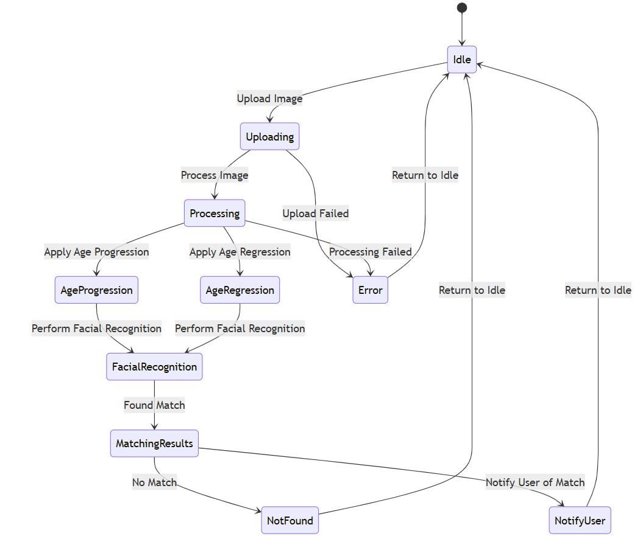

### 4- Class Diagram

This diagram outlines the structure of the system by defining the objects, attributes, and relationships.

